**오라클 외부접속 허용**

**1.경로**

C:\app\21class-007\product\11.2.0\dbhome_1\NETWORK\ADMIN

**2. tnsnames.ora, listener.ora.수정**

**listener.ora**

**:localhost를 ip(192.168.0.33)로 변경.**

**# listener.ora Network Configuration File: C:\app\21class-007\product\11.2.0\dbhome_1\network\admin\listener.ora**

**# Generated by Oracle configuration tools.**

**SID_LIST_LISTENER =**

**(SID_LIST =**

**(SID_DESC =**

**(SID_NAME = CLRExtProc)**

**(ORACLE_HOME = C:\app\21class-007\product\11.2.0\dbhome_1)**

**(PROGRAM = extproc)**

**(ENVS = "EXTPROC_DLLS=ONLY:C:\app\21class-007\product\11.2.0\dbhome_1\bin\oraclr11.dll")**

**)**

**)**

**LISTENER =**

**(DESCRIPTION_LIST =**

**(DESCRIPTION =**

**(ADDRESS = (PROTOCOL = IPC)(KEY = EXTPROC1521))**

**(ADDRESS = (PROTOCOL = TCP)(HOST = localhost)(PORT = 1521))**

**)**

**)**

**ADR_BASE_LISTENER = C:\app\21class-007**

**tnsnames.ora**

**:localhost를 ip(192.168.0.33)로 변경.**

**# tnsnames.ora Network Configuration File: C:\app\21class-007\product\11.2.0\dbhome_1\network\admin\tnsnames.ora**

**# Generated by Oracle configuration tools.**

**LISTENER_MYORACLE =**

**(ADDRESS = (PROTOCOL = TCP)(HOST = localhost)(PORT = 1521))**

**ORACLR_CONNECTION_DATA =**

**(DESCRIPTION =**

**(ADDRESS_LIST =**

**(ADDRESS = (PROTOCOL = IPC)(KEY = EXTPROC1521))**

**)**

**(CONNECT_DATA =**

**(SID = CLRExtProc)**

**(PRESENTATION = RO)**

**)**

**)**

**MYORACLE =**

**(DESCRIPTION =**

**(ADDRESS = (PROTOCOL = TCP)(HOST = localhost)(PORT = 1521))**

**(CONNECT_DATA =**

**(SERVER = DEDICATED)**

**(SERVICE_NAME = myoracle)**

**)**

**)**

**3. service 재시작**

**(OracleServiceDB , OracleOraDb11g_home1TNSListener)**

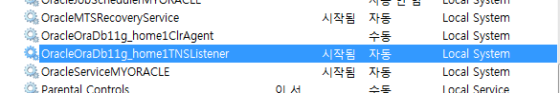

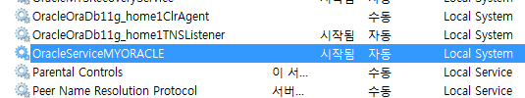

**3. 재접속(호스트 이름이 localhost가 아니라 192.168.0.33으로 변경.)**

